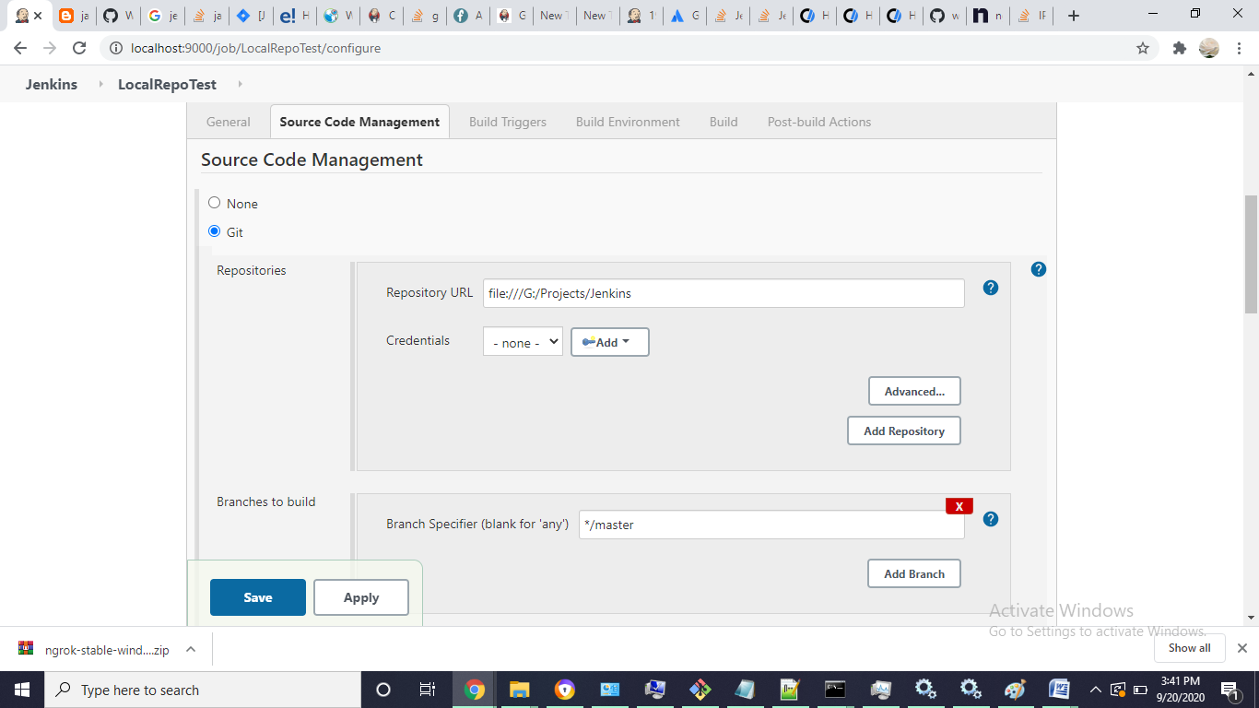

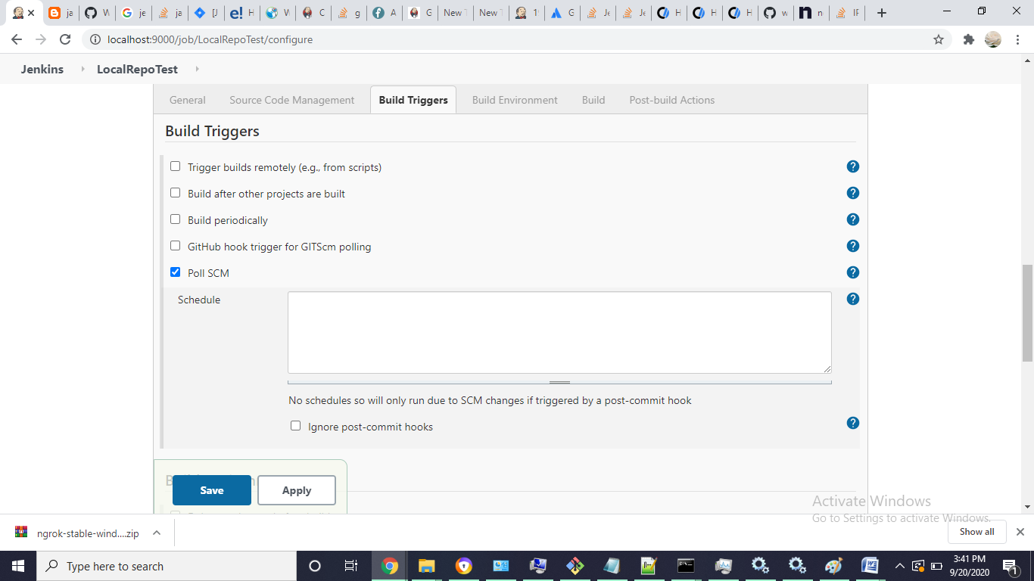

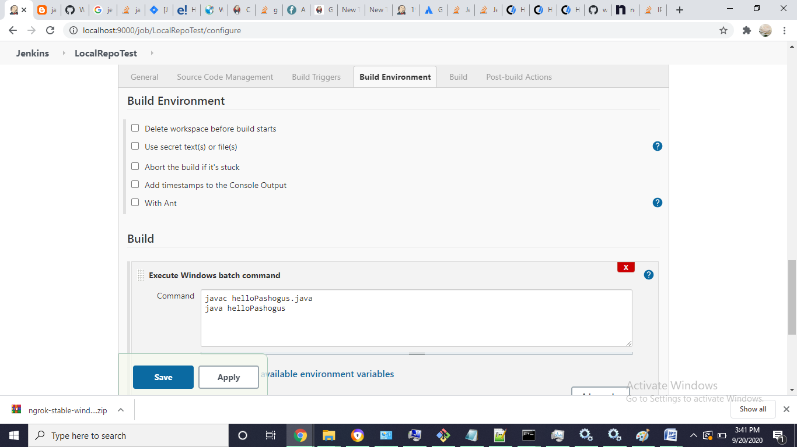

<http://192.168.1.10:9000/git/notifyCommit?url=file:///G:/Projects/Jenkins>

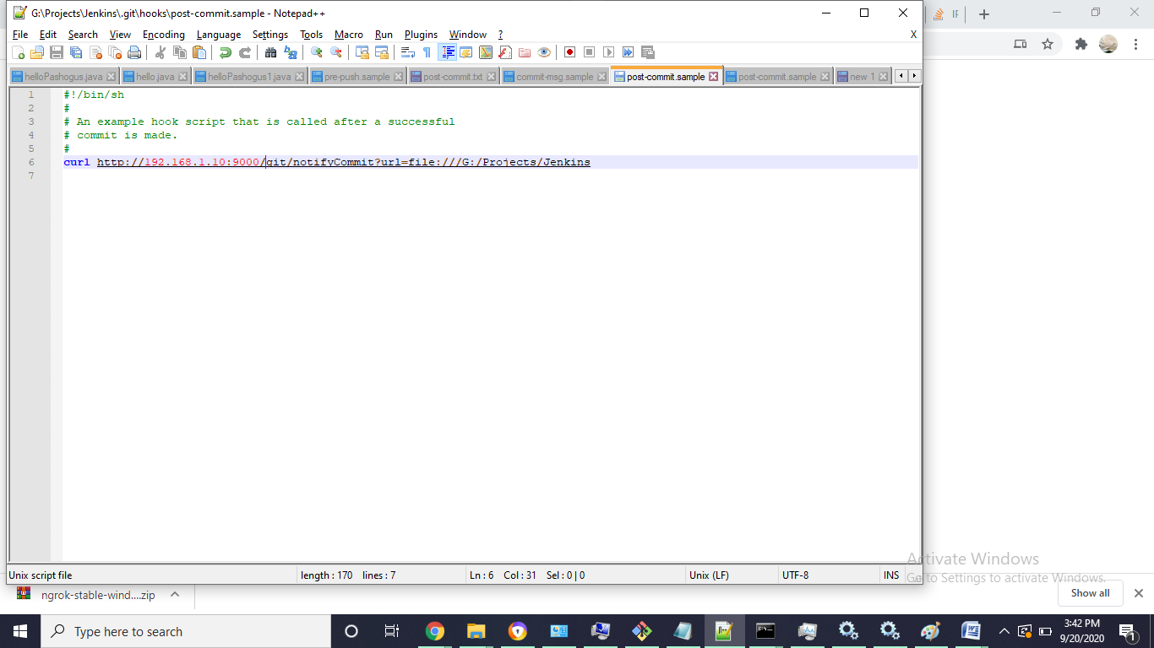

Ref

<https://stackoverflow.com/questions/10498554/jenkins-linking-to-my-local-git-repository>

<https://plugins.jenkins.io/git/>

<https://stackoverflow.com/questions/10121098/jenkins-configure-jenkins-to-poll-changes-in-scm>